**Saturday** (Robo Truck)

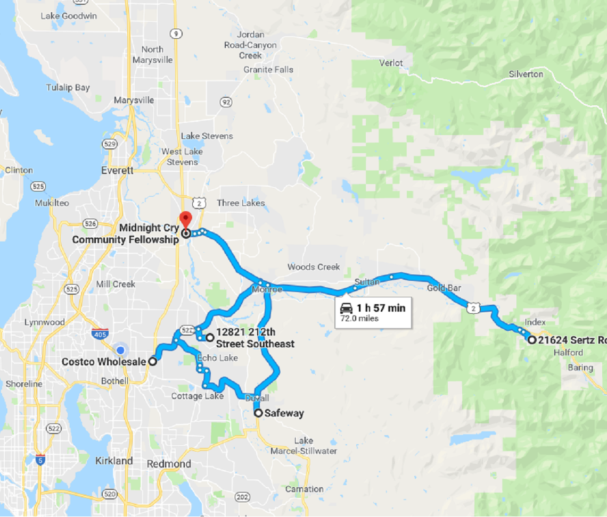

Notes: